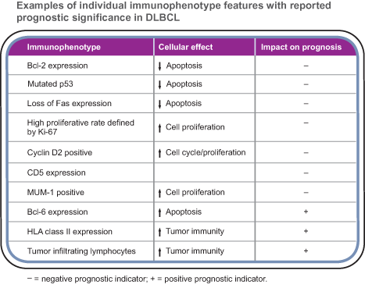
DLBCL Panels:

Diagnostic:
- BCL-1
- CD3
- CD5
- CD20 or PAX-5

Prognostic:
- BCL-2
- BCL-6
- CD10
- CD138
- cMYC
- MUM-1
- p53

Therapy Effect: In the Germ Center B-cell group (GCB), there was no significant difference in survival rates in patients receiving R-CHOP and CHOP therapy (P > 0.05). In the non-GCB group, the survival rate in patients treated with R-CHOP therapy was significantly longer than those treated with CHOP therapy (5-year survival rate, 62.8 % vs 30.8 %, P < 0.05). Immunophenotype classification is also useful in selecting the chemotherapy protocol.

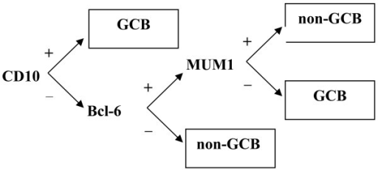

Positivity is defined as >30% expression (except for cMYC with is >50%)

Prognosis:
- Favorable: germinal center gene expression (GCB = BCL6+ or CD10+, negative for MUM1 and CD138) vs. the poorer prognosis for the activated B cell-like profile (Am J Surg Pathol 2004;28:464)
- Unfavorable (Am J Clin Path 2001;116:183):
  - 1) CD10+ or BCL-6+ with co-expression of MUM-1 or CD138 (intermediate activation)
  - 2) MUM-1+ or CD138+ without expression of CD10 or BCL-6 (activated profile)
- Unfavorable: p53+, CD5+, BCL-2+, high Ki-67
- Unfavorable: c-MYC expression (>50% of cells). Not overcome by rituximab therapy.
  - There is consensus that MYC translocations confer a worse prognosis in patients with DLBCL treated with cyclophosphamide, doxorubicin, vincristine, and prednisone (CHOP), both in combination with and without rituximab. MYC-break positive DLBCL cases may also coexpress high levels of BCL2, and up to half of these cases have a concurrent translocation involving BCL2. These so-called double hit (DH) DLBCLs have a dismal prognosis (http://jco.ascopubs.org/content/30/28/3433.full)
- Very Unfavorable: c-MYC with increased BCL-2 (“double hit DLBCLs” – see above).

